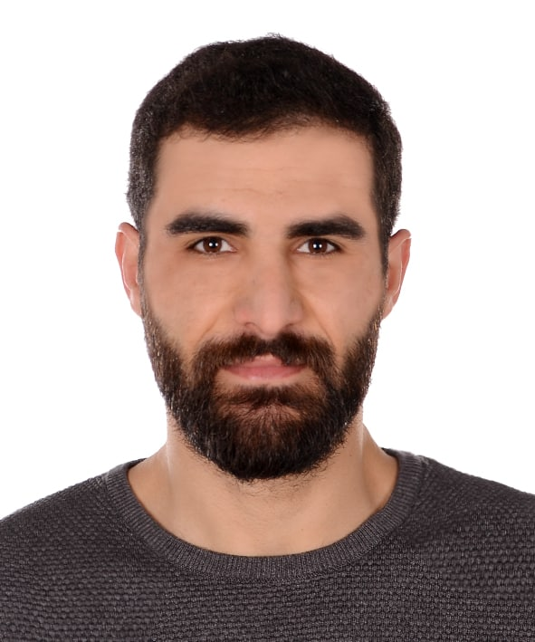Ali MUNGAN

+90 552 232 61 94  
+49 152 119 00 391 [ali.mungan1@gmail.com](mailto:ali.mungan1@gmail.com)

# Work Experience

**Appen -** *Audio & handwriting transcription*

### 

### Freelance - *Arabic-Turkish Translator (Over 5 years of experience in consecutive interpretation at conferences, trade fairs, hospitals, universities, and charitable organizations)*

### 

### Arfen Bridge Kocaeli *- Sales Representative*

### 

### Türev Construction İstanbul *- Construction Site Engineer*

### 

### İMO Chamber of Civil Engineers *- Civil Engineer*

### İnc Engineering *- Technical Office Engineer*

### IHH Humanitarian Relief Foundation *- Project Assistant*

# Skills

Sap2000, AutoCAD , İdeCAD ,Excel, Word, Powerpoint, ect…

Google (Sheets, Docs, Drive, Mail, Forms, ect...)

### Education

## 08 2016 - 08 2021

### Kocaeli University , Kocaeli *- Bachelor's Degree* Civil Engineering

# Courses

**Project Management** Elginkan Foundation

**Communication Skills**  Elginkan Foundation

**Proposal Writing**  Google Workshop

**Introduction to Programming with Java** BTK Academy

**Digital Marketing**  Google Workshop

**Cost and Management Accounting**  Elginkan Foundation

**deCAD Structural Foundation Training** Chamber of Civil Engineers

**Building Earthquake Regulations - 2018** Chamber of Civil Engineers

# Languages

# Fluent in Arabic , Fluent in Turkish , Intermediate level in English .Beginner in the German language

# 